**HMR INSTITUTE OF TECHNOLOGY & MANAGEMENT**



***MAJOR PROJECT***

On

**Credit Card Fraud Detection System**

**Using Machine Learning**

Submitted in partial fulfillment of the

Requirements for the award of

**Degree of Bachelor of Technology**

**In**

**ELECTRONICS & COMMUNICATION ENGINEERING**

**GUIDE: Submitted by:**

**Mr. PAWAN BHUTANI IRA SHARMA (47013302816)**

**MUDITA SHARMA (48513302816)**

**HARSHITA SHARMA (35813302816)**

**Credit Card Fraud Detection System**

**Introduction:**

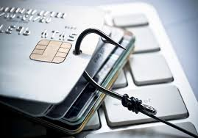Due to rapid advancement in the electronic commerce technology, the use of credit cards has dramatically increased. As credit card becomes the most popular mode of payment for both online as well as regular purchase, cases of fraud associated with it are also rising.

Credit-card-based purchases can be categorized into two types: 1) Physical card 2) Virtual card. In a physical-card-based purchase, the card holder presents the card physically to a merchanr for making a paymet. To carry out fraudulent transactions in this kind of purchase, an attacker has to steal the credit card. In the second kind of purchase, only some important information about a card number, expiration date, security code etc. is required to make the payment. Such purchases are normally done on the internet or over the telephone. To commit fraud in these types of purchases, a fraudster simply needs to know the card details. Most of the time, the genuine cardholder is not aware that someone else has seen or stolen his card information. The only way to detect this kind of fraud is to analyze the spending patterns on every card and to figure out any inconsistency with respect to the “usual” spending patterns.

Fraud detection based on the analysis of existing purchase data of cardholder is a promising way to reduce the rate of successful credit card frauds. Since humans tend to exhibit specific behaviorist profiles, every cardholder can be represented by a set of patterns containing information about the typical purchase category, the time since the last purchase, the amount of money spent, etc. Deviation from such patterns is a potential threat to the system.

**Problem Statement:**

With the great facility to buy anything, anywhere without money or with virtual money, Credit card brings the successful fraud transactions too.

**Review of literature:**

In proposed system, Behavior and Location Analysis (BLA) concept will be used, which does not require fraud signatures and yet is able to detect frauds by considering a cardholder’s spending habit. Card transaction processing sequence will be noticed by the stochastic process of a BLA. The details of items purchased in Individual transactions are usually not known to any Fraud Detection System (FDS) running at the bank that issues credit cards to the cardholders. Hence, BLA will be an ideal choice for addressing this problem. Another important advantage of the BLA -based approach is a drastic reduction in the number of False Positives transactions identified as malicious by an FDS although they are actually genuine. An FDS runs at a credit card issuing bank. Each incoming transaction is submitted to the FDS for verification. FDS receives the card details and the value of purchase to verify, whether the transaction is genuine or not. The types of goods that are bought in that transaction are not known to the FDS. It tries to find any anomaly in the transaction based on the spending profile of the cardholder, shipping address, and billing address, etc. If the FDS confirms the transaction to be of fraud, it raises an alarm, and the issuing bank declines the transaction.

The credit card fraud detection features uses user behavior and location scanning to check for unusual patterns. These patterns include user characteristics such as user spending patterns as well as usual user geographic locations to verify his identity. If any unusual pattern is detected, the system requires re-verification.

The system analysis uses credit card data for various characteristics. These characteristics include user country, usual spending procedures. Based upon previous data of that user the system recognizes unusual patterns in the payment procedure. So now the system may require the user to login again or even block the user for more than 3 invalid attempts.

**Core Features:**

* The system stores previous transaction patterns for each user.
* Based upon the user spending ability and even country, it calculates user’s characteristics.
* More than 20 -30 % deviation of user’s transaction (spending history and operating country) is considered as an invalid attempt and system takes action.

**Significance/How the project works? :**

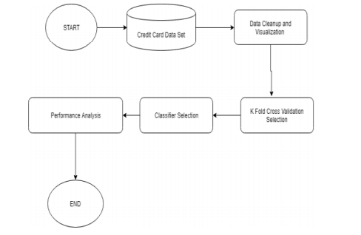

**Objectives:**

To reduce the rate of successful credit card frauds.

**Software Requirements:**

* Windows 10
* Jupyter notebook
* Python basics

**Advantages:**

* Due to Behavior and location analysis approach, there is a drastic reduction in the number of False Positives transactions identified as malicious by an FDS although they are actually genuine.
* The system stores previous transaction patterns for each user.
* Based upon previous data of that user the system recognizes unusual patterns in the payment procedure.
* The System will block the user for more than 3 invalid attempts.